REPORTS – STATEMENT OF PROFIT OR LOSS

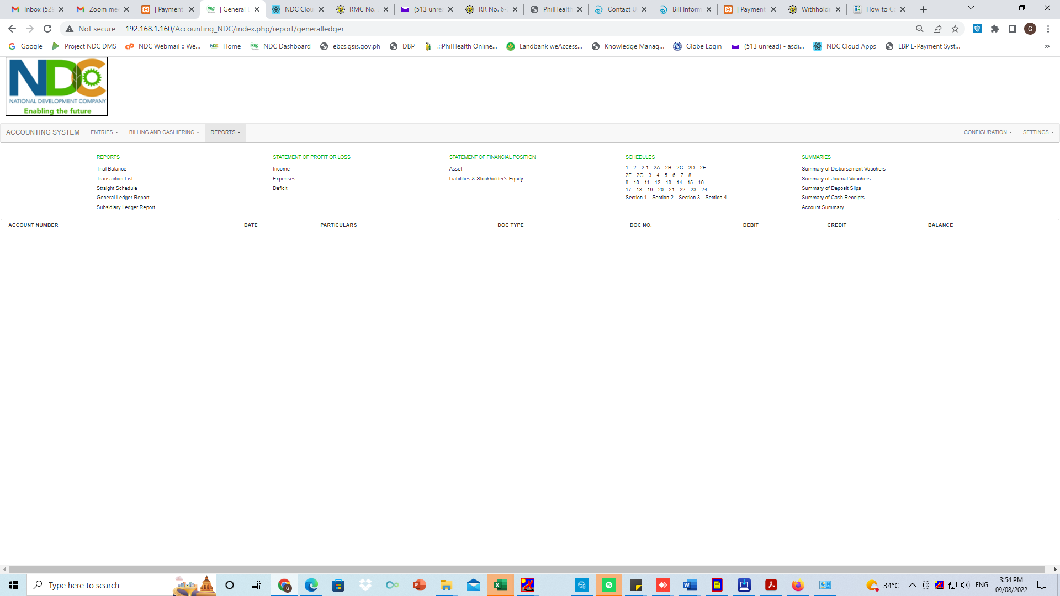

STATEMENT OF PROFIT OR LOSS

* INCOME

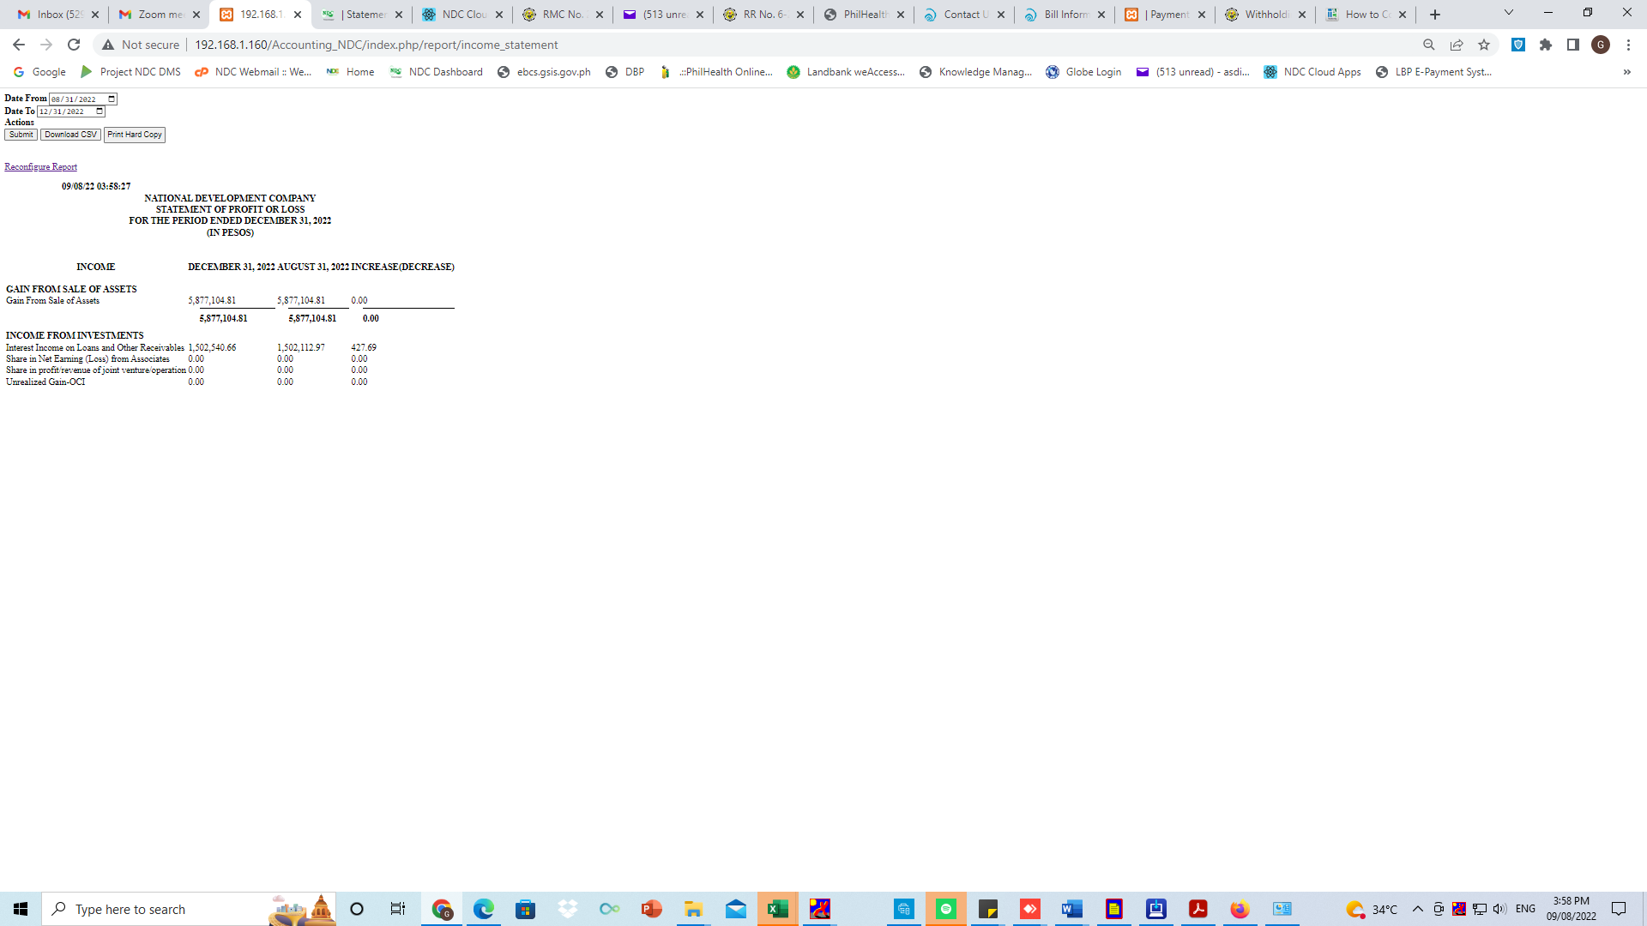

STATEMENT OF PROFIT OR LOSS

* EXPENSES

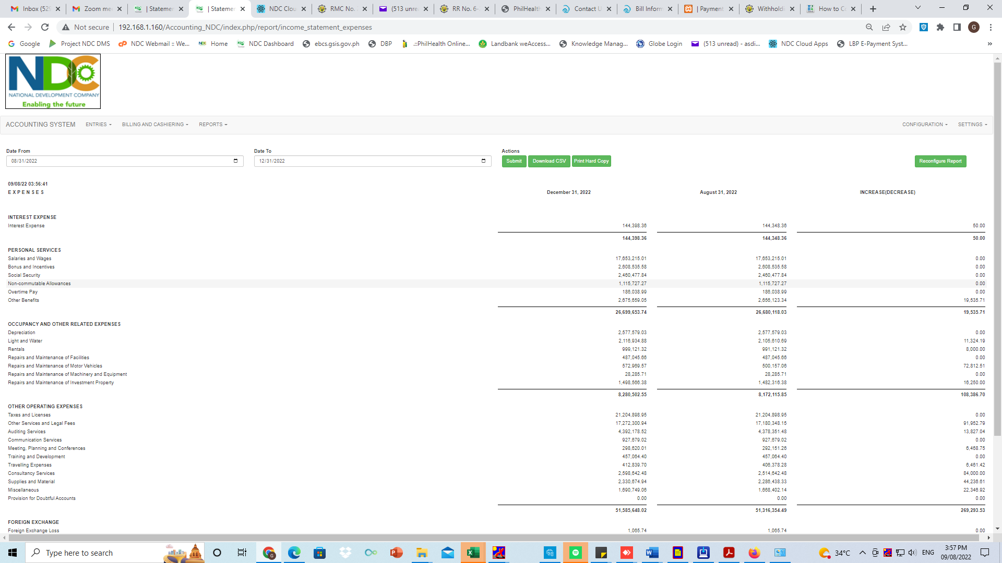

STATEMENT OF PROFIT OR LOSS

* DEFICIT

